(Approx. 351 words)

WaveLink Wireless Doorbell
By George Harding, Treasurer, Tucson Computer Society
March 10, 2018
www.aztcs.org/
actuary110 (at) yahoo.com

I received this product for review. It has several parts: a plug-in unit that produces the bell sound, two buttons, a motion detector and a door open/close alert sensor.

This product is very easy to install and use. The plug-in unit simply plugs in to a wall outlet and is ready to use. It has two buttons on its side, one for a selection of tones, the other for volume. The tone selection is extensive, consisting of 52 different tones and 4 volume levels.

The two buttons are simple affairs, with a quarter-sized button that lights up when you press it. Each button can be attached to a wall or a door frame with wood screws, anchors or with double-sided tape. Screws, anchors, and tape are supplied. The buttons are each powered by a small 12v alkaline battery.

The motion detector senses motion and triggers the doorbell. Thus, you get an advance warning of a visitor. It is powered by two AAA batteries. The unit attaches with a small plate that screws to a wall and has a movable ball attached, so that the detector can be pointed in any direction.
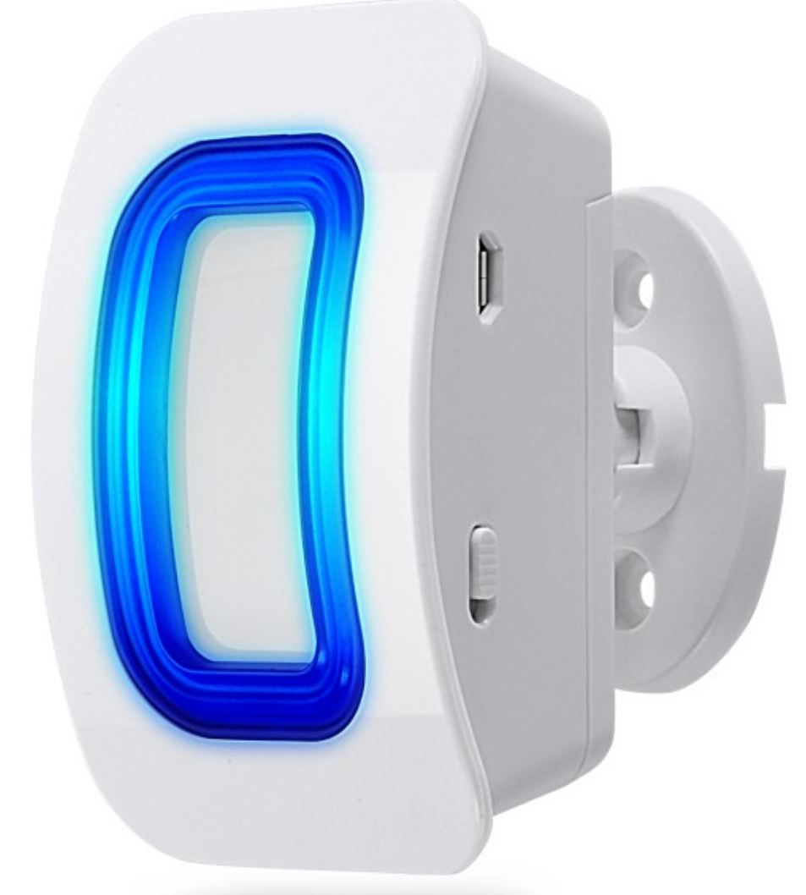
Lastly, the door alert sensor comes in two parts, a thin piece, about 3/4th inch wide and 3 inches long. The other piece is about twice as wide and is powered by a AA battery. The narrow piece attaches to the door and the larger piece attaches to the frame. When the door opens, the bell rings, giving you an alert that the door has been opened. The two pieces are attached using screws, anchors or double-sided tape.

This kit, consisting of bell, buttons, sensor and alert unit, is easy to set up and install. I had some trouble figuring out how to pair the motion detector to the bell unit, but I was given access to a YouTube video explaining the procedure, which gave me what I needed.

WaveLink Wireless Doorbell by Fosmon www.fosmon.com

Price varies by components in package, $15-$35

